CIT438/538
Lab#05: AWS Auto Scaling

In this lab, you will study Amazon Auto Scaling. You will use AWS CLI to configure Auto Scaling with Amazon EC2 and ELB.

Tools and Materials
- One Ubuntu VM on the vSphere servers
- AWS CLI

Note: You need to replace words in italics with your information.
Questions will be in red. Make sure to show your work.

Part 1: Scale Up

    - Log into your VM. Go to the directory where you keep the apache-install script file that you created in Lab 1.

    - Create a launch config via the following command:

aws ec2 create-launch-template \
--launch-template-name your_username-template \
--version-description initial-version \
--launch-template-data '{
"ImageId": "ami-013f17f36f8b1fefb",
"InstanceType": "t2.micro",
"KeyName": "your_key",
"NetworkInterfaces": [{
"DeviceIndex": 0,
"AssociatePublicIpAddress": true,
"Groups": ["your_sec_grp_id"]
}],
"UserData": "'$(base64 -w0 apache.sh)'"
}'

aws ec2 create-launch-template \
--launch-template-name hazlettsammy-template \
--version-description initial-version \
--launch-template-data "{
\"ImageId\": \"ami-013f17f36f8b1fefb\",
\"InstanceType\": \"t3.micro\",
\"KeyName\": \"usersam2-key\",
\"NetworkInterfaces\": [{
\"DeviceIndex\": 0,
\"AssociatePublicIpAddress\": true,
\"Groups\": [\"sg-0e8b8b55ca4766f03\"]
}],
\"UserData\": \"$(base64 -w0 apache.sh)\"
}"

What is the output?
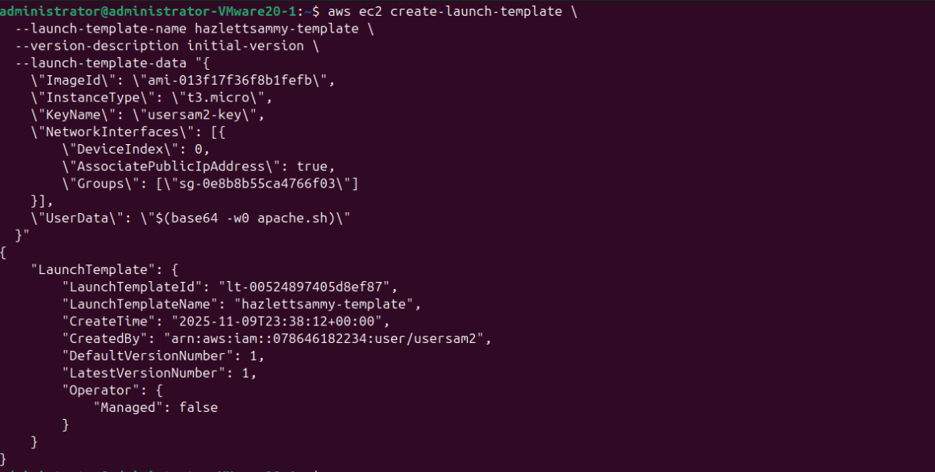

{
"LaunchTemplate": {
"LaunchTemplateId": "lt-00524897405d8ef87",
"LaunchTemplateName": "hazlettsammy-template",
"CreateTime": "2025-11-09T23:38:12+00:00",
"CreatedBy": "arn:aws:iam::078646182234:user/usersam2",
"DefaultVersionNumber": 1,
"LatestVersionNumber": 1,
"Operator": {
"Managed": false
}
}
}

    - Create a load balancer via the following command:

aws elb create-load-balancer --load-balancer-name your_username \
--listeners "Protocol=HTTP,LoadBalancerPort=80,InstanceProtocol=HTTP,InstancePort=80" \
--subnets your_useast1a_subnet_id --security-groups your_sec_grp_id

aws elb create-load-balancer --load-balancer-name hazlettsammy\
--listeners "Protocol=HTTP,LoadBalancerPort=80,InstanceProtocol=HTTP,InstancePort=80" \
--subnets subnet-048109d99999c8dae --security-groups sg-0e8b8b55ca4766f03
What is the output?
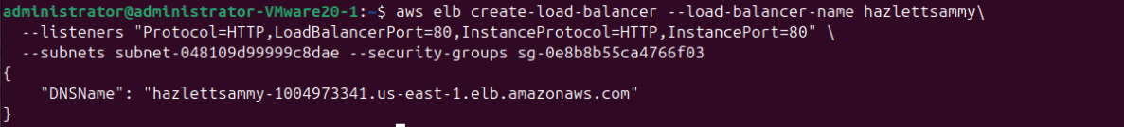

{
"DNSName": "hazlettsammy-1004973341.us-east-1.elb.amazonaws.com"
}

    - Create an auto scaling group via the following command:

aws autoscaling create-auto-scaling-group \
--auto-scaling-group-name kochjt-asg \
--launch-template LaunchTemplateName=your_template_name-template,Version='$Latest' \
--min-size 1 \
--max-size 3 \
--desired-capacity 1 \
--vpc-zone-identifier your_subnet_ID

aws autoscaling create-auto-scaling-group \
--auto-scaling-group-name kochjt-asg \
--launch-template LaunchTemplateName=hazlettsammy-template,Version='$Latest' \
--min-size 1 \
--max-size 3 \
--desired-capacity 1 \
--vpc-zone-identifier subnet-048109d99999c8dae

What is the output?
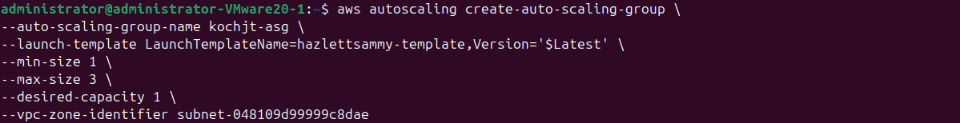

    - Describe the auto scaling group via the following command:

aws autoscaling describe-auto-scaling-groups --auto-scaling-group-name your_username-asg
aws autoscaling describe-auto-scaling-groups --auto-scaling-group-name kochjt-asg

What is the output? You should see a new EC2 instance is created. If you don’t see it, please wait for 2 minutes and run the command again. What is the instance ID?
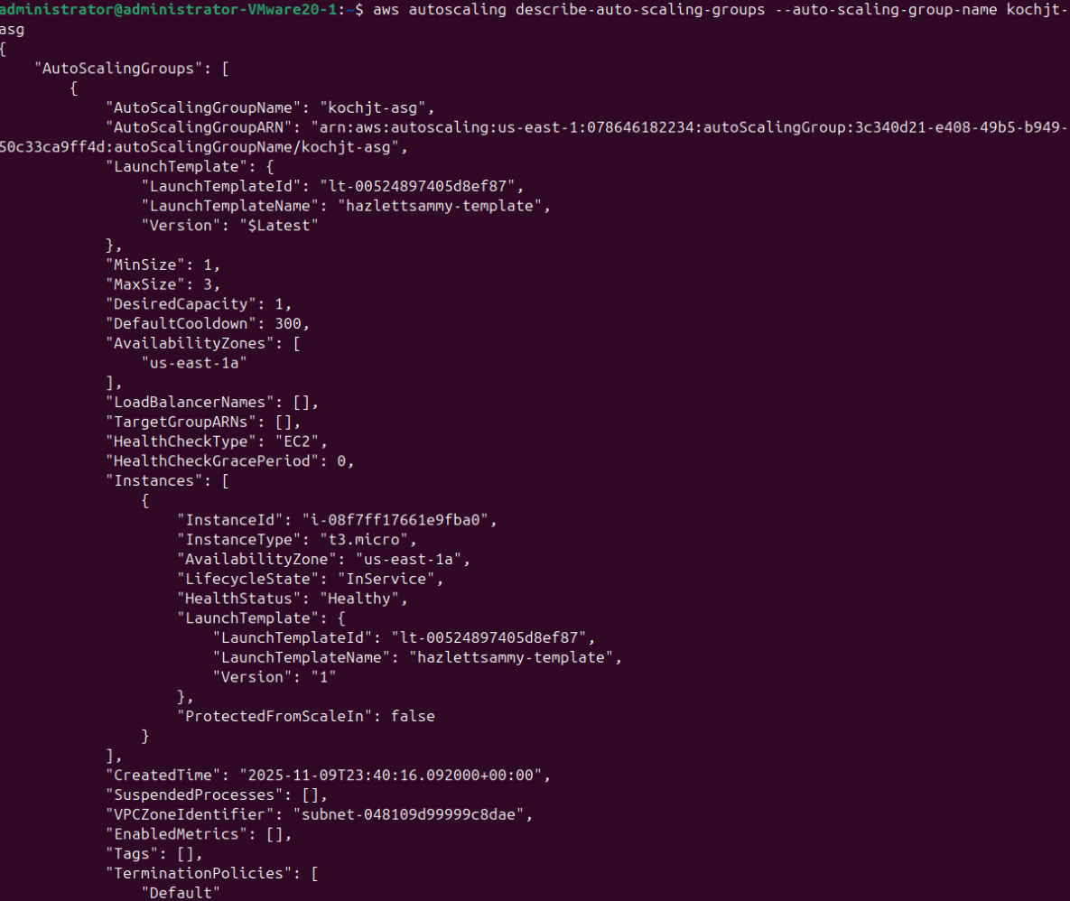
{
"AutoScalingGroups": [
{
"AutoScalingGroupName": "kochjt-asg",
"AutoScalingGroupARN": "arn:aws:autoscaling:us-east-1:078646182234:autoScalingGroup:3c340d21-e408-49b5-b949-50c33ca9ff4d:autoScalingGroupName/kochjt-asg",
"LaunchTemplate": {
"LaunchTemplateId": "lt-00524897405d8ef87",
"LaunchTemplateName": "hazlettsammy-template",
"Version": "$Latest"
},
"MinSize": 1,
"MaxSize": 3,
"DesiredCapacity": 1,
"DefaultCooldown": 300,
"AvailabilityZones": [
"us-east-1a"
],
"LoadBalancerNames": [],
"TargetGroupARNs": [],
"HealthCheckType": "EC2",
"HealthCheckGracePeriod": 0,
"Instances": [
{
"InstanceId": "i-08f7ff17661e9fba0",
"InstanceType": "t3.micro",
"AvailabilityZone": "us-east-1a",
"LifecycleState": "InService",
"HealthStatus": "Healthy",
"LaunchTemplate": {
"LaunchTemplateId": "lt-00524897405d8ef87",
"LaunchTemplateName": "hazlettsammy-template",
"Version": "1"
},
"ProtectedFromScaleIn": false
}
],
"CreatedTime": "2025-11-09T23:40:16.092000+00:00",
"SuspendedProcesses": [],
"VPCZoneIdentifier": "subnet-048109d99999c8dae",
"EnabledMetrics": [],
"Tags": [],
"TerminationPolicies": [
"Default"
],
"NewInstancesProtectedFromScaleIn": false,
"ServiceLinkedRoleARN": "arn:aws:iam::078646182234:role/aws-service-role/autoscaling.amazonaws.com/AWSServiceRoleForAutoScaling",
"TrafficSources": [],
"AvailabilityZoneDistribution": {
"CapacityDistributionStrategy": "balanced-best-effort"
},
"CapacityReservationSpecification": {
"CapacityReservationPreference": "default"
}
}
]
}

Instance ID is: i-08f7ff17661e9fba0

    - Create a scale-up policy via the following command:

aws autoscaling put-scaling-policy --auto-scaling-group-name your_username-asg --policy-name your_username-scaleup --scaling-adjustment 1 --adjustment-type ChangeInCapacity --cooldown 120

aws autoscaling put-scaling-policy \
--auto-scaling-group-name kochjt-asg \
--policy-name kochjt-scaleup \
--scaling-adjustment 1 \
--adjustment-type ChangeInCapacity \
--cooldown 120 \
--region us-east-1

What is the output? What is the value of PolicyARN? (The value is a long string without quote characters). You need this value for next step.
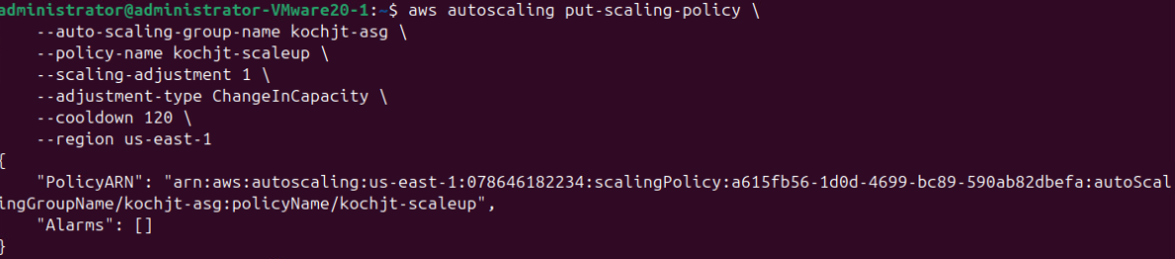
{
"PolicyARN": "arn:aws:autoscaling:us-east-1:078646182234:scalingPolicy:a615fb56-1d0d-4699-bc89-590ab82dbefa:autoScalingGroupName/kochjt-asg:policyName/kochjt-scaleup",
"Alarms": []
}

    - Create an alarm to trigger the scale-up policy via the following command:

aws cloudwatch put-metric-alarm --alarm-name your_username-highcpualarm --metric-name CPUUtilization --namespace AWS/EC2 --statistic Average --period 120 --threshold 70 --comparison-operator GreaterThanThreshold --dimensions "Name=AutoScalingGroupName,Value= your_username-asg" --evaluation-periods 1 --alarm-actions value_of_PolicyARN

aws cloudwatch put-metric-alarm \
--alarm-name kochjt-highcpualarm \
--metric-name CPUUtilization \
--namespace AWS/EC2 \
--statistic Average \
--period 120 \
--threshold 70 \
--comparison-operator GreaterThanThreshold \
--dimensions Name=AutoScalingGroupName,Value=kochjt-asg \
--evaluation-periods 1 \
--alarm-actions arn:aws:autoscaling:us-east-1:078646182234:scalingPolicy:a615fb56-1d0d-4699-bc89-590ab82dbefa:autoScalingGroupName/kochjt-asg:policyName/kochjt-scaleup \
--region us-east-1

When is asks for the policyarn in the command use this part of your answer as in the example below:

arn:aws:autoscaling:us-east-1:829564731560:scalingPolicy:3c338af8-4aa7-4878-ba64-c7e93316e8c0:autoScalingGroupName/kochj9-asg:policyName/kochj9-scaleup

What is the output?
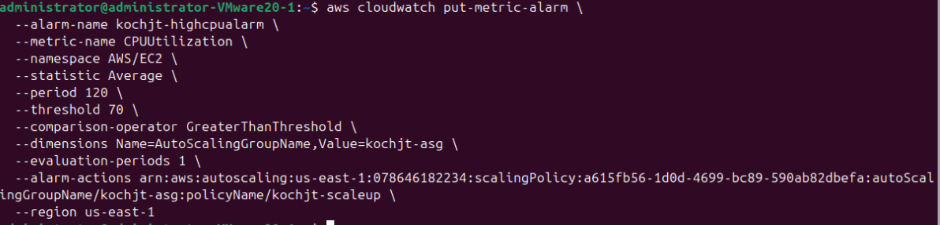

    - Describe the alarm via the following command:

aws cloudwatch describe-alarms --alarm-names your_username-highcpualarm
aws cloudwatch describe-alarms --alarm-names kochjt-highcpualarm

What is the output?
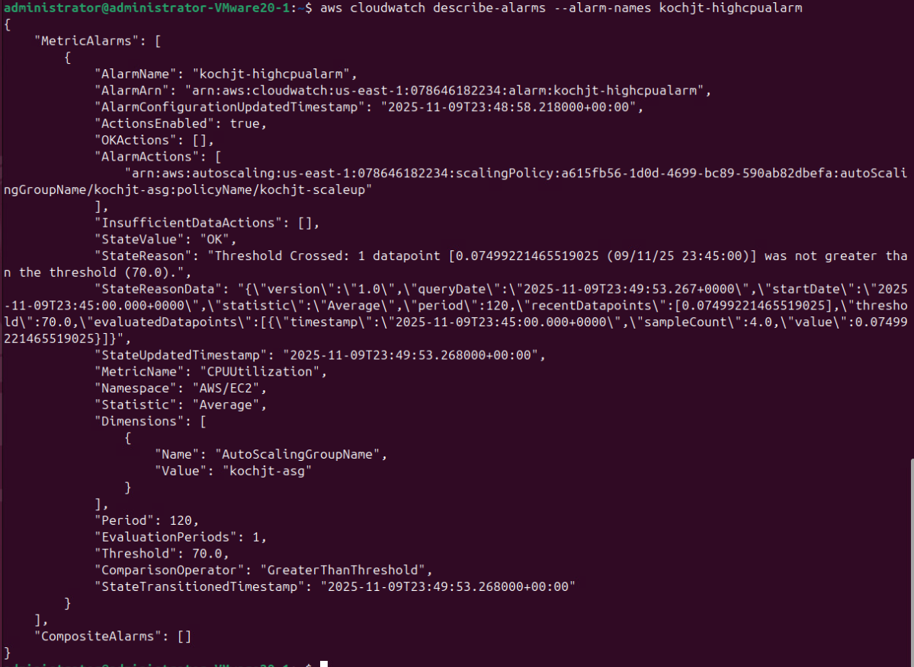
{
"MetricAlarms": [
{
"AlarmName": "kochjt-highcpualarm",
"AlarmArn": "arn:aws:cloudwatch:us-east-1:078646182234:alarm:kochjt-highcpualarm",
"AlarmConfigurationUpdatedTimestamp": "2025-11-09T23:48:58.218000+00:00",
"ActionsEnabled": true,
"OKActions": [],
"AlarmActions": [
"arn:aws:autoscaling:us-east-1:078646182234:scalingPolicy:a615fb56-1d0d-4699-bc89-590ab82dbefa:autoScalingGroupName/kochjt-asg:policyName/kochjt-scaleup"
],
"InsufficientDataActions": [],
"StateValue": "OK",
"StateReason": "Threshold Crossed: 1 datapoint [0.07499221465519025 (09/11/25 23:45:00)] was not greater than the threshold (70.0).",
"StateReasonData": "{\"version\":\"1.0\",\"queryDate\":\"2025-11-09T23:49:53.267+0000\",\"startDate\":\"2025-11-09T23:45:00.000+0000\",\"statistic\":\"Average\",\"period\":120,\"recentDatapoints\":[0.07499221465519025],\"threshold\":70.0,\"evaluatedDatapoints\":[{\"timestamp\":\"2025-11-09T23:45:00.000+0000\",\"sampleCount\":4.0,\"value\":0.07499221465519025}]}",
"StateUpdatedTimestamp": "2025-11-09T23:49:53.268000+00:00",
"MetricName": "CPUUtilization",
"Namespace": "AWS/EC2",
"Statistic": "Average",
"Dimensions": [
{
"Name": "AutoScalingGroupName",
"Value": "kochjt-asg"
}
],
"Period": 120,
"EvaluationPeriods": 1,
"Threshold": 70.0,
"ComparisonOperator": "GreaterThanThreshold",
"StateTransitionedTimestamp": "2025-11-09T23:49:53.268000+00:00"
}
],
"CompositeAlarms": []
}

    - Log into the EC2 instance via ssh. You can find out the instance id from step 5. This terminal becomes an EC2 instance terminal. Switch to root. Install a stress Linux tool via the following commands:

ssh -i /home/administrator/usersam2.pem ubuntu@44.201.238.98

apt-get install stress

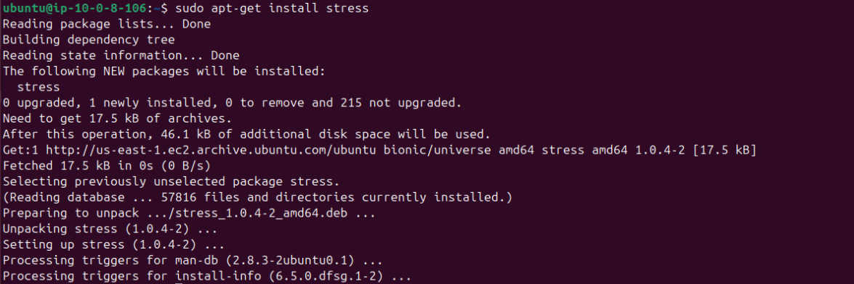
Please run “stress --cpu 1” to generate workload so that you can see the scale-up process.

    - Start a new VM terminal. Repeat the following command every 2 minutes until you see the second EC2 instance and the third EC2 instance are created in your auto scaling group.

aws autoscaling describe-auto-scaling-groups --auto-scaling-group-name your_username-asg
aws autoscaling describe-auto-scaling-groups --auto-scaling-group-name kochjt-asg

What is the output?

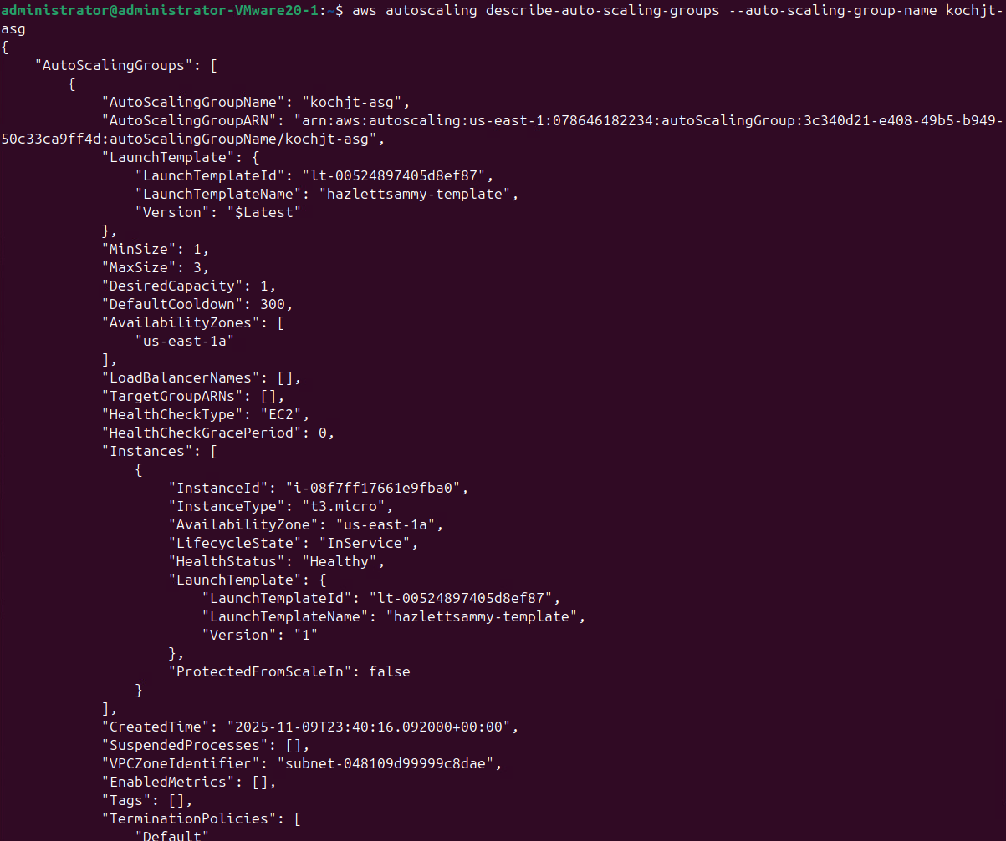
Part 2: Scale Down

    - Create a scale-down policy via the following command:

aws autoscaling put-scaling-policy --auto-scaling-group-name your_username-asg --policy-name your_username-scaledown --scaling-adjustment -1 --adjustment-type ChangeInCapacity --cooldown 120

aws autoscaling put-scaling-policy --auto-scaling-group-name kochjt-asg --policy-name kochjt-scaledown --scaling-adjustment -1 --adjustment-type ChangeInCapacity --cooldown 120

What is the output? What is the value of PolicyARN? (The value is a long string without quote characters). You need this value for next step.
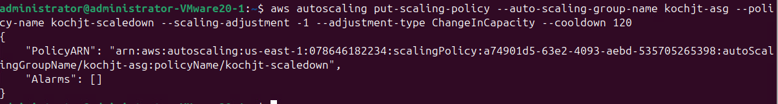
{
"PolicyARN": "arn:aws:autoscaling:us-east-1:078646182234:scalingPolicy:a74901d5-63e2-4093-aebd-535705265398:autoScalingGroupName/kochjt-asg:policyName/kochjt-scaledown",
"Alarms": []
}

    - Create an alarm to trigger the scale-down policy via the following command:

aws cloudwatch put-metric-alarm --alarm-name kochjt-lowcpualarm --metric-name CPUUtilization --namespace AWS/EC2 --statistic Average --period 120 --threshold 30 --comparison-operator LessThanThreshold --dimensions "Name=AutoScalingGroupName,Value= kochjt-asg" --evaluation-periods 1 --alarm-actions arn:aws:autoscaling:us-east-1:078646182234:scalingPolicy:a74901d5-63e2-4093-aebd-535705265398:autoScalingGroupName/kochjt-asg:policyName/kochjt-scaledown

What is the output?

    - Switch to the EC2 instance terminal. Please type Ctl-C to stop the stress command (workload) so that you can see the scale-down process.

    - Switch back to the VM terminal. Repeat the following command every 2 minutes until you see only one EC2 in your auto scaling group:

aws autoscaling describe-auto-scaling-groups --auto-scaling-group-name your_username-asg
aws autoscaling describe-auto-scaling-groups --auto-scaling-group-name kochjt-asg

What is the output?
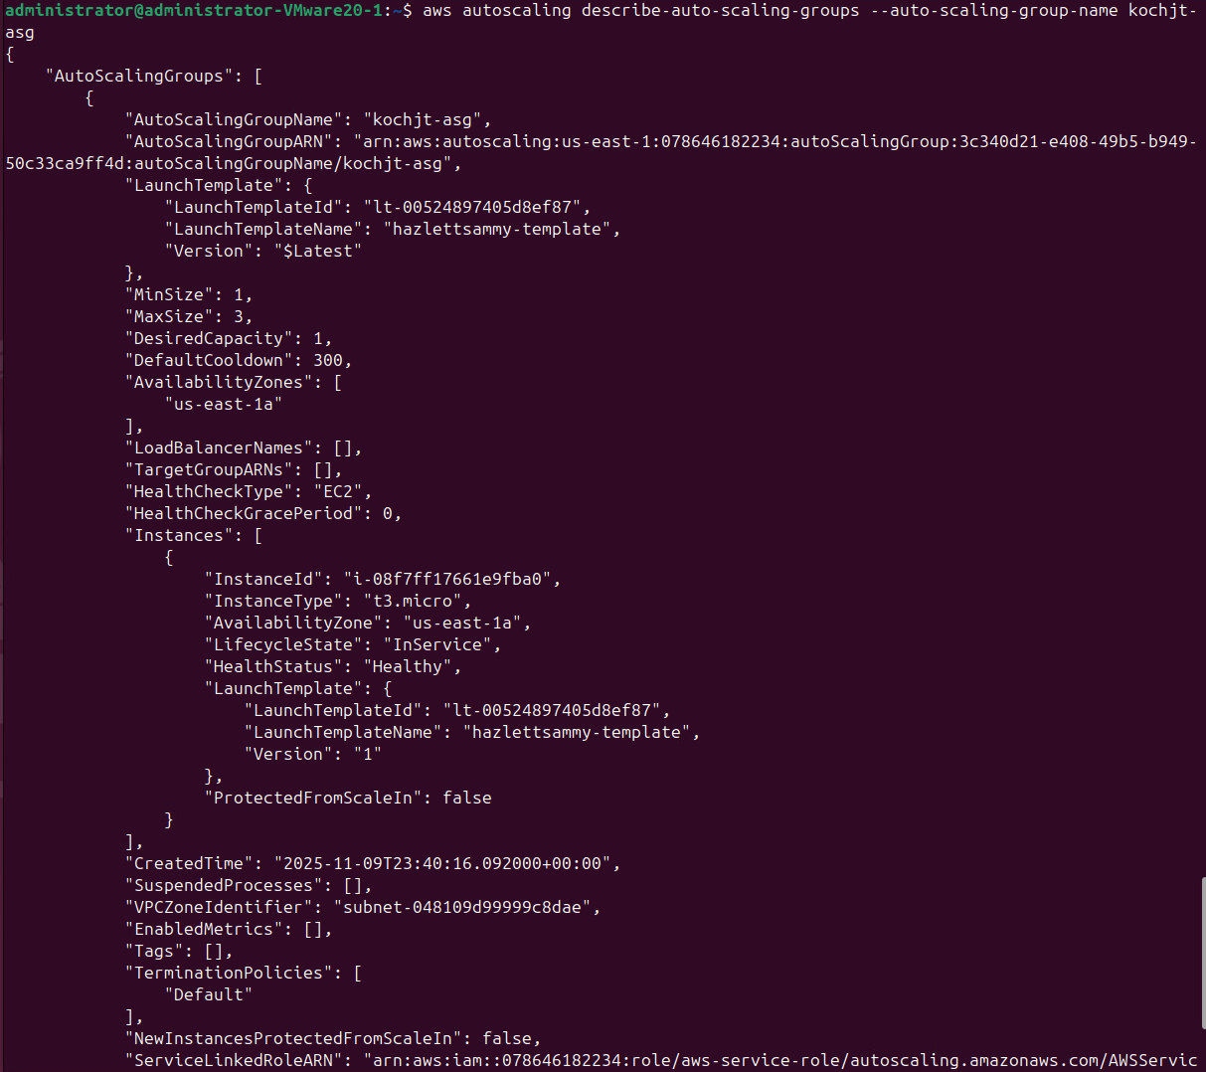
{
"AutoScalingGroups": [
{
"AutoScalingGroupName": "kochjt-asg",
"AutoScalingGroupARN": "arn:aws:autoscaling:us-east-1:078646182234:autoScalingGroup:3c340d21-e408-49b5-b949-50c33ca9ff4d:autoScalingGroupName/kochjt-asg",
"LaunchTemplate": {
"LaunchTemplateId": "lt-00524897405d8ef87",
"LaunchTemplateName": "hazlettsammy-template",
"Version": "$Latest"
},
"MinSize": 1,
"MaxSize": 3,
"DesiredCapacity": 1,
"DefaultCooldown": 300,
"AvailabilityZones": [
"us-east-1a"
],
"LoadBalancerNames": [],
"TargetGroupARNs": [],
"HealthCheckType": "EC2",
"HealthCheckGracePeriod": 0,
"Instances": [
{
"InstanceId": "i-08f7ff17661e9fba0",
"InstanceType": "t3.micro",
"AvailabilityZone": "us-east-1a",
"LifecycleState": "InService",
"HealthStatus": "Healthy",
"LaunchTemplate": {
"LaunchTemplateId": "lt-00524897405d8ef87",
"LaunchTemplateName": "hazlettsammy-template",
"Version": "1"
},
"ProtectedFromScaleIn": false
}
],
"CreatedTime": "2025-11-09T23:40:16.092000+00:00",
"SuspendedProcesses": [],
"VPCZoneIdentifier": "subnet-048109d99999c8dae",
"EnabledMetrics": [],
"Tags": [],
"TerminationPolicies": [
"Default"
],
"NewInstancesProtectedFromScaleIn": false,
"ServiceLinkedRoleARN": "arn:aws:iam::078646182234:role/aws-service-role/autoscaling.amazonaws.com/AWSServiceRoleForAutoScaling",
"TrafficSources": [],
"AvailabilityZoneDistribution": {
"CapacityDistributionStrategy": "balanced-best-effort"
},
"CapacityReservationSpecification": {
"CapacityReservationPreference": "default"
}
}
]
}

Part 3: Cleanup

    - Delete the auto scaling group via the following command. If the group has instances or scaling activities in progress, you must specify the option to force the deletion for it to succeed. If the group has policies, deleting the group deletes the policies, the underlying alarm actions, and any alarm that no longer has an associated action.

aws autoscaling delete-auto-scaling-group --auto-scaling-group-name your_username-asg --force-delete
aws autoscaling delete-auto-scaling-group --auto-scaling-group-name kochjt-asg --force-delete

    - Delete both alarms via the following commands:

aws cloudwatch delete-alarms --alarm-name your_username-lowcpualarm
aws cloudwatch delete-alarms --alarm-name kochjt-lowcpualarm

What is the output?
aws cloudwatch delete-alarms --alarm-name your_username-highcpualarm
aws cloudwatch delete-alarms --alarm-name kochjt-highcpualarm

What is the output?

    - Delete your config via the following command:

aws ec2 delete-launch-template --launch-template-name your_username-template
aws ec2 delete-launch-template --launch-template-name hazlettsammy-template

What is the output?
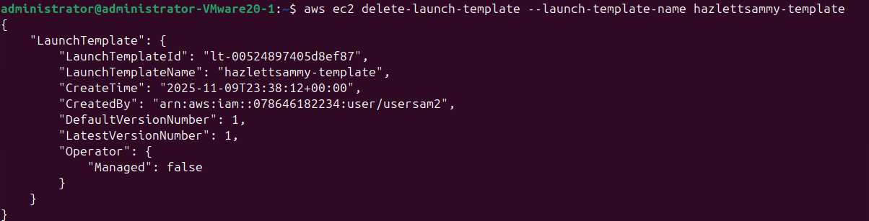
{
"LaunchTemplate": {
"LaunchTemplateId": "lt-00524897405d8ef87",
"LaunchTemplateName": "hazlettsammy-template",
"CreateTime": "2025-11-09T23:38:12+00:00",
"CreatedBy": "arn:aws:iam::078646182234:user/usersam2",
"DefaultVersionNumber": 1,
"LatestVersionNumber": 1,
"Operator": {
"Managed": false
}
}
}

    - Delete the ELB. What command did you run?

aws elb delete-load-balancer --load-balancer-name hazlettsammy-elb --region us-east-1

Submission instruction

After completing this work, submit this word document with your answers to the Blackboard. In your word document, your answers should be in blue print.

